Task 3: Class diagram and design pattern

1.1 Class diagram:

Link: [https://lucid.app/lucidchart/f794bcd8-c781-46be-bf65-964b70a35311/edit?invitationId=inv_d3d92ae7-68db-4769-abd2-cc6080d97224&page=0_0#](https://lucid.app/lucidchart/f794bcd8-c781-46be-bf65-964b70a35311/edit?invitationId=inv_d3d92ae7-68db-4769-abd2-cc6080d97224&page=0_0)

1.2 Design pattern:

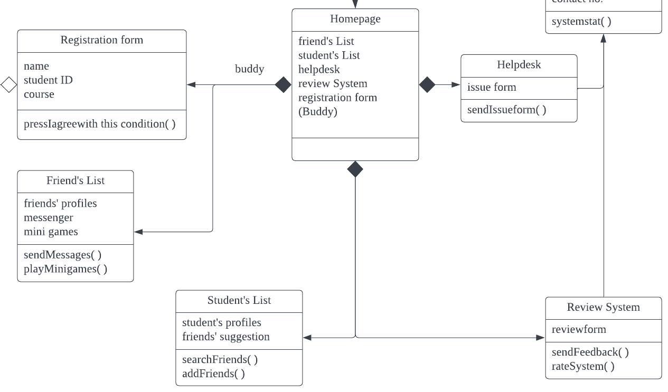

**Figure 1.2 Facade, Design Pattern**

The design pattern that I chose is facade. Facade is a structural design pattern that gives a streamlined interface to a collection, framework, or any other complex collection of classes. This design pattern implemented in this Figure 1.2 because facade can simplify the complex of homepage class’s framework and hides the underlying subsystem classes that are Registration Form, Friend’s List, Student’s List, Review System and Helpdesk. At homepage, the system class will show the subsystem class to the users. So, this will be flexible for the users to click in the subsystem and view the content of the subsystem class. If there is no homepage, then the function ability of subsystem classes is unable to operate because subsystem classes are multiple dependencies within homepage class.